by
Prospective Educator
Information Pack

Prospective Educator Information Pack Content List | Page
Contents | 1
Why Educators choose to partner with Baulkham Hills Family Day Care | 2
What do I need to establish a Family Day Care Business?  Qualifications for Family Day Care Educators  Other establishment requirements | 3
How to apply to become an Educator with Baulkham Hills Family Day Care? | 3
Interview process | 4
Training designed to assist Educators to establish a successful Family Day Care business | 4
Completion of establishment process and registration | 4
How does Baulkham Hills Family Day Care support Educators? | 5
What costs may I incur when establishing my Family Day Care business? | 6
What income can Family Day Care Educators receive and what ongoing costs will I incur?  Educator income and Admin Levy fees  How are Educator payments made?  Public liability Insurance  Fire equipment checking  Qualifications renewal  Toys and Equipment  Taxation | 6 – 7
How many children can a Family Day Care Educator provide care for? | 8
Frequently asked questions about Family Day Care  What is Family Day Care?  Can my own children attend my Family Day Care service?  What duties are Family Day Care Educators responsible for?  Can I set my own working hours?  How are placements made for my Family Day Care business?  Can I take children on excursions?  What happens if I take holiday leave or are unable to work?  What is Play Session?  What is glass compliance about?  What is a Residual Current Device (RCD)?  Can I have pets?  Can my family members or friends supervise the children in care for me?  Can I provide meals for children in care?  Can my friends and/or other Educators with children visit my Family Day Care service? | 8 – 10
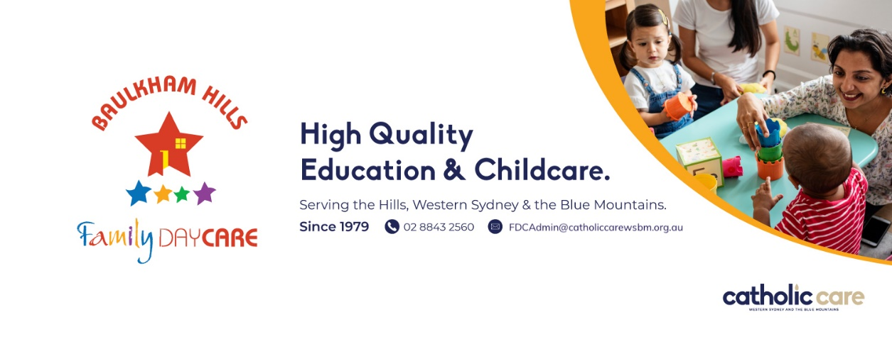

Why Educators choose to partner with Baulkham Hills Family Day Care

Baulkham Hills Family Day Care has a great reputation with clients and is highly respected within the Family Day Care industry.

As the largest provider of Family Day Care in The Hills and surrounding districts Baulkham Hills Family Day Care has the largest client base, which results in more placement referrals for Baulkham Hills Family Day Care Educators than any other local provider!

Baulkham Hills Family Day Care is the premier Family Day Care provider in The Hills and surrounding districts which has earnt the local community’s trust since 1979.

Baulkham Hills Family Day Care offers an experienced Family Day Care team that supports Educators to establish and grow a successful Family Day Care business. Baulkham Hills Family Day Care has effective and efficient administration processes ensuring that the Educator payment processing is managed proficiently. Baulkham Hills Family Day Care also offers ‘relief care’ for clients for when Educators take leave, thereby providing Educators the opportunity to take leave and retain clientele (‘Relief care’ subject to availability).

Baulkham Hills Family Day Care has the largest advertising and marketing presence in The Hills and surrounding districts and can assist Educators to advertise and market their business successfully. Baulkham Hills Family Day Care can assist Educators with advertising strategies and individualised advertising artwork.

Like us on Facebook https://www.facebook.com/hillsfamilydaycare/

Baulkham Hills Family Day Care has a strong presence in Western Sydney and The Hills, and is expanding beyond these locations…


What do I need to establish a Family Day Care Business?
Qualifications for Family Day Care Educators
- Minimum Certificate 3 in early childhood education and care. Diploma or Bachelor qualification desirable.
- First Aid include asthma and anaphylaxis valid 3 years.
- CPR (Cardiopulmonary Resuscitation) valid for 1 year.
- Working with Children Check for paid employment.
- Working with Children Check for volunteers for all adult household members.

Other establishment requirements
- Obtain Landlord permission to use a rental property.
- Check Bushfire prone land status of premises with local Council.
- Read the ‘Educator Role Description’.
- Read the ‘Prospective Educators Information Pack’.
- Public liability insurance (Obtained at the end of the establishment process).
- Medical certificate stating fitness for childcare duties (Obtained later in the establishment process).

Baulkham Hills Family Day Care supplies details for all of the above information during the application process.
How to apply to become an Educator with Baulkham Hills Family Day Care?
Please complete the supplied forms and return them to Baulkham Hills Family Day Care.
- Application form
- Questionnaire for Educators Partner
- Landlord permission to use rental property (if necessary)

 | Applications can be submitted to:  Baulkham Hills Family Day Care  Level 2, 10 Victoria Rd, Parramatta 2151  Or  fdcadmin@catholiccarewsbm.org.au  Contact (02) 8843 2560 for further details.


Interview process
The friendly experienced staff at Baulkham Hills Family Day Care are keen to meet you and to assist you to set up a successful Family Day Care business. To assist this process, interviews are conducted at your premises. During an interview you can expect to be asked about your experience with children and given guidance on safety requirements for the premises. The interview is also a great opportunity for you to ask questions about how Family Day Care works and what to expect working within the industry.
Training designed to assist Educators to establish a successful Family Day Care business
To help you establish your Family Day Care business to be successful over the long term, Baulkham Hills Family Day Care delivers ‘start up’ training for prospective Educators. Training is typically delivered over two sessions and is individually tailored to your needs. Experienced Educators may be given credit for prior learning.  Baulkham Hills Family Day Care also provides ‘start up’ resources including policies, Law, Regulations, National Quality Standards, EYLF, MTOP, mandatory display items, posters, forms and community resources. | 
Completion of establishment process and registration
Our friendly staff are available to support you throughout the process. Baulkham Hills Family Day Care will request copies of your qualifications and other regulatory documentation periodically. Once your Family Day Care service is set up Baulkham Hills Family Day Care will complete a risk assessment of the premises, finalise your fee schedule and provide registration documentation. From this point your Family Day Care service will be open for business!
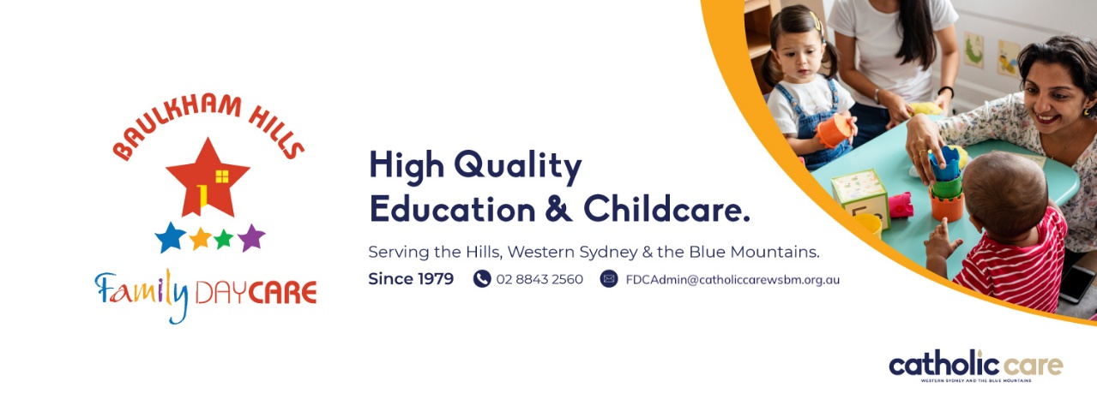


How does Baulkham Hills Family Day Care support Educators?
- Baulkham Hills Family Day Care has the largest client base within the Hills and surrounding district.
- The experienced staff provides daily support to Educators and clients using the service.
- Weekly processing of payments to ensure regular cash flow for Educators.
- Registration with Baulkham Hills Family Day Care allows your Family Day Care business to offer Government rebates (CCs/ACCS) to eligible clients.
- Clear fee schedule and written agreements between the service and clients to assist payment expectations.
- Fee estimator application exclusively for Baulkham Hills Family Day Care Educators.
- Strong marketing and advertising presence for Baulkham Hills Family Day Care.
- Administration of waiting list and providing client referrals to Educators.
- Enrolment of children into Baulkham Hills Family Day and management of enrolment legal requirements.
- Relief care positions, for your clients, when you are on leave (subject to availability).
- Baulkham Hills Family Day Care maintains much of the administrative requirements for FDC businesses.
- Policy and procedure designed to achieve quality outcomes for both Educators and clients.
- Educators have their own Educator Support Specialist (ESS) whom can support you to provide quality Family Day Care services.
- ESS team provide regular feedback to clients using the service.
- Access to an extensive toy library and group play session opportunities.
- Support in navigating the requirements of Family Assistance Law, Education and Care Services National Law & Regulations and the National Quality Standards.
- Training opportunities facilitated periodically to assist Educators to manage a successful FDC business.
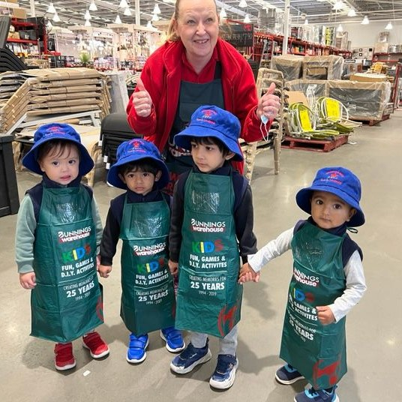 | 

What costs may I incur when establishing my Family Day Care business?
As with any new business some capital is required when starting up. The list below outlines some of the expenses you may incur during start up but is not exhaustive.
- Adaptations to the premises to comply with safety Regulation.
- Glass compliance and certificate.
- Residual-Current Device (RCD) compliance and certificate.
- ‘Start up’ training and orientation fee (up to $300).
- Public Liability Insurance (details provided).
- Safety equipment including fire extinguisher & blanket, first aid kit, stair barrier & other safety devices.
- Resources such as cot/s, highchair, child-sized table &chairs, mattresses and cleaning products etc.
- Vehicle restraint inspection report and child seats to Australian Standard (only if travelling by vehicle).
- Play equipment and resources for children (indoor and outdoor). For example:
Home corner | Dress ups | Blocks | Push/pull toys | Musical Instruments
Toddle truck | Craft materials | Construction toys | Cars/Trucks | Dolls and Babies
Puzzles | Books | Drawing materials | Music | Manipulative toys
Ride on toys | Climbing equip. | Balls | Sandpit | Buckets & spades
Natural resources | Balance beam | Hoops | Water trough | Cubby house
(Please note that play equipment must be 50cm high or less to comply with safety regulations.)

What income can Family Day Care Educators receive and what ongoing costs will I incur?
Unlike many Family Day Care providers, Baulkham Hills Family Day Care does not charge Educators annual registration fees, annual training fees, timesheet processing & amendment fees, weekly Educator levy or advertising fees.

Baulkham Hills Family Day Care has an Admin Levy which is included in the hourly rate charged to clients. The Admin Levy finances the operation of Baulkham Hills Family Day Care, which in turn supports Educators and clients.

Educator income and Admin Levy fees
The Baulkham Hills Family Day Care Admin Levy is included in the hourly rate charged to clients. For example, if the hourly rate charged to clients is $12.00 per hour per child and the Admin Levy is $2.00 per hour per child, then the Educator receives $10.00 per hour per child in care. Please ask Baulkham Hills Family Day Care staff for current information about the Admin Levy rate and the hourly fees Educators can expect to charge clients. Please note that setting hourly rates is dependent upon many factors.

Educator income can be estimated by calculating the hourly rate (minus the Admin Levy) multiplied by the hours of care provided per day per child, multiplied by the number of children in care per day, multiplied by the number of days providing care per week (e.g. $10.00 per hour x 9 hours per day x 4 children x 5 days = $1800 per week).
Please note that Educator income is dependent on many factors including being able to meet client expectations.

How are Educator payments made?
Fees are payable on a weekly basis after attendance record submission and MUST be paid Electronically by Direct Debit with all transaction fees/surcharges/dishonour fees payable by parent/Guardian.
Fees must be paid in accordance with the individual Educator’s Fee Schedule.
Families who receive CCS are required to make a co-contribution to their childcare fees under Family Assistance Law.
Families using childcare must pay the gap fee or Full fee when CCS is not applied, using Direct Debit, established within the Approve Providers third party software. The gap fee is the difference between the provider’s fee and the Child Care Subsidy (CCS) amount.


Public liability Insurance
Public liability insurance is an annual expense, and the cost is dependent on the level of cover obtained. Information on insurance providers and associated costs will be supplied to you separately.

Fire equipment checking
Regulation require that fire equipment used within a Family Day Care business is checked by a qualified operator every 6 months in accordance with the Australian Standard. Baulkham Hills Family Day Care offers this service to Educators at a fixed price, which is significantly less than that charged by third party fire services companies. Baulkham Hills Family Day Care provides fire equipment checking services free for new Educators for the first 6 months.

Qualifications renewal
- First aid qualifications, including asthma and anaphylaxis, are updated every 3 years.
- CPR qualifications are updated year 12 months.
- Working with Children Check for paid employment is updated every 5 years.
- Criminal History Checks, are updated every 3 years (or at Service discretion)

Toys and Equipment
It is necessary to replace toys and equipment as they age or become unfit for the intended purpose. While most Family Day Care Educators start with a good range of resources, it may be necessary to add to these periodically.

Taxation
The Australian Tax Office considers Educators as self-employed contractors and not employees of Baulkham Hills Family Day Care. Therefore Educators are responsible for paying tax on earning and for maintaining adequate financial records. Baulkham Hills Family Day Care cannot advise you on specific financial arrangements and responsibilities, and as such recommends that you engage an accountant or tax agent to assist. In general, Educators are able to make many tax deductions associated with operating a business from home including a portion of electricity, rent/interest payments, business costs, resources and cleaning etc.


How many children can a Family Day Care Educator provide care for?
The maximum number of children, per Family Day Care premises, cannot exceed the allowance specified in the Education and Care Services National Regulation 2011. That is, under typical circumstances, ratio requirements allow one (1) Educator to provide education and care for up to seven (7) children at any one time, of which four (4) can be under school age and three (3) over school age, including the Educator’s own children. Once children turn 13 years old they are no longer included in Educator ratios. Please note that all children attending the Family Day Care service, whom are under the supervision of the registered Educator, must be enrolled in Baulkham Hills Family Day Care.

Frequently asked questions about Family Day Care
What is Family Day Care?  - Family Day Care is when an individual, known as an Educator, establishes a Family Day Care service operating from their own home or approved venue.  - Family Day Care is a licensed and regulated industry under the Department of Education and Training.  - Family Day Care is subject to the same Laws and Regulations as Long Day Care services.  - Family Day Care has the potential of providing flexible care days and times to suit atypical requirements.  - Family Day Care Educators and premises must be registered by an Approved Service (e.g. Baulkham Hills Family Day Care) to be able to offer Government rebates (CCS/ACCS) to clients. Approved Services are sponsored by an Approved Provider. The Approved Provider for Baulkham Hills Family Day Care is CatholicCare Western Sydney and The Blue Mountains Parramatta Diocese. | Sponsor Structure  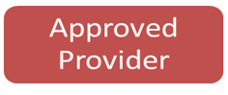  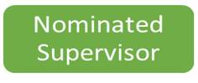  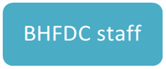  

Can my own children attend my Family Day Care service?
Yes, Family Day Care is a great way to balance caring for your own children and earning an income. Please note that Government benefits cannot be claimed for your own children.

What duties are Family Day Care Educators responsible for?
- Please see the ‘Educator Role Description’ for details.

Can I set my own working hours?
Yes, you can decide which days and hours you are prepared to work. For example, some Educators operate during the day catering to under school age children. While other Educators operate ‘Before and After School’ services catering to school age children. Please note that the availability of the Family Day Care service directly impacts the success of the business.

How are placements made for my Family Day Care business?
As the largest provider of Family Day Care services in The Hills and surrounding areas, Baulkham Hills Family Day Care has the largest client base to assist Family Day Care Educators with placement. Baulkham Hills Family Day Care may refer clients to you whom are seeking a Family Day Care position for their child. Baulkham Hills Family Day Care also provides training on strategic ways to assist your Family Day Care business to obtain clients.

Can I take children on excursions?
Yes. Excursions are a great way to engage with the local community and explore learning opportunities with children. All excursions need to be child orientated and the location suitable for children. Baulkham Hills Family Day Care will assist you in achieving the necessary regulatory requirements before any excursions are undertaken.

What happens if I take holiday leave or are unable to work?
Everyone needs to take leave at some point, and we encourage Educators to do so responsibly in accordance with Baulkham Hills Family Day Care policy. Unfortunately, because Family Day Care Educators are self-employed, if the service is closed for any reason fees cannot be charged to clients. Baulkham Hills Family Day Care offers temporary relief care positions to clients, subject to availability, so that the client can still access care and the Educator can take leave without losing clients.

What is Play Session?
Play Session is a facility organised by Baulkham Hills Family Day Care to accommodate larger group gatherings of children and their Educators. These events are great opportunities for children to extend social skills and for Educators to build professional support networks with peers. These play sessions are done in a virtual capacity, out in the community as a mobile session and 1:1 in Educators residences.

What is glass compliance about?
Under the Education and Care Services National Law & Regulations all panes of glass located from 750mm high down to ground/floor level, within areas accessible to children, must be either safety glass or treated with a clear film by a qualified professional to meet the Australian Standard. Window tinting companies can supply this service and provide you with a compliance certificate. Alternatively, glass can be securely barricaded off to restrict children’s access.

What is a Residual Current Device (RCD)?
An RCD is the electrical safety switch installed in most premises. A statement from a qualified professional outlining that the RCD is operational is required as part of Family Day Care registration.

Can I have pets?
Yes. Pets need to have a separate area which is inaccessible for children in care. With written parent permission children in care can have supervised access to pets that are appropriate for children.

Can my family members or friends supervise the children in care for me?
No. Children in care must be supervised by the registered Educator at all times. The Education and Care Services National Regulations states that children must be within sight and/or hear of the Educator at all times.

Can I provide meals for children in care?
Currently within Baulkham Hills Family Day Care clients provide healthy and nutritious food for their children. Educators are able to cut up fruit or warm up food for children. Educators are also able to organise cooking activities as part of the programing experiences. To be able to cook and provide full meals for children, Educators must complete an audit from the NSW Health Department and maintain these requirements. To provide any meals to children in your care, you must complete the Food Safety Supervisor Certificate, via the Food Authority NSW (SITSS00069).

Can my friends and/or other Educators with children visit my Family Day Care service?
Yes, other people can visit your Family Day Care business during operational hours but any children accompanying these people must be supervised by another adult, not the Educator. Remember that Family Day Care Educators are subject to ratio requirements and that all children supervised by an Educator must be enrolled in Baulkham Hills Family Day Care. This is also a professional business, and the children should always be your priority.


